|  |  |  |  |  |  |
| --- | --- | --- | --- | --- | --- |
| Date | 9-Dec-22 | | | Tester Name | Janette Paus |
| Environment | Penfax - Test 2 | | | Login used |  |
| Operating System | Windows | Version: 21H2 | Update Number: | | |
| Software Used | Select Software | Version: 107.0.1418.56 | Update Number: | | |
| Select Software | Version: | Update Number: | | |
| Application Release version | R22.4.1 | | | | |
| Test Case Title | E20.08 | | | | |
| Test Type | Regression | | | | |
| Test Scenario | Backdate an Interfund Transfer | | | | |
| Expected Results | To process an interfund transfer that has a previous date to it (effective date a previous day). To check the breakage log to ensure it shows on the report and is reasonable.  To confirm that the unit values used in the interfund were the ones on the effective date (not the process date) and that the funds/units were moved correctly. | | | | |
| Pass/Fail | Pass | | | JIRA# |  |

Search for an active PEPP member

SID 307888

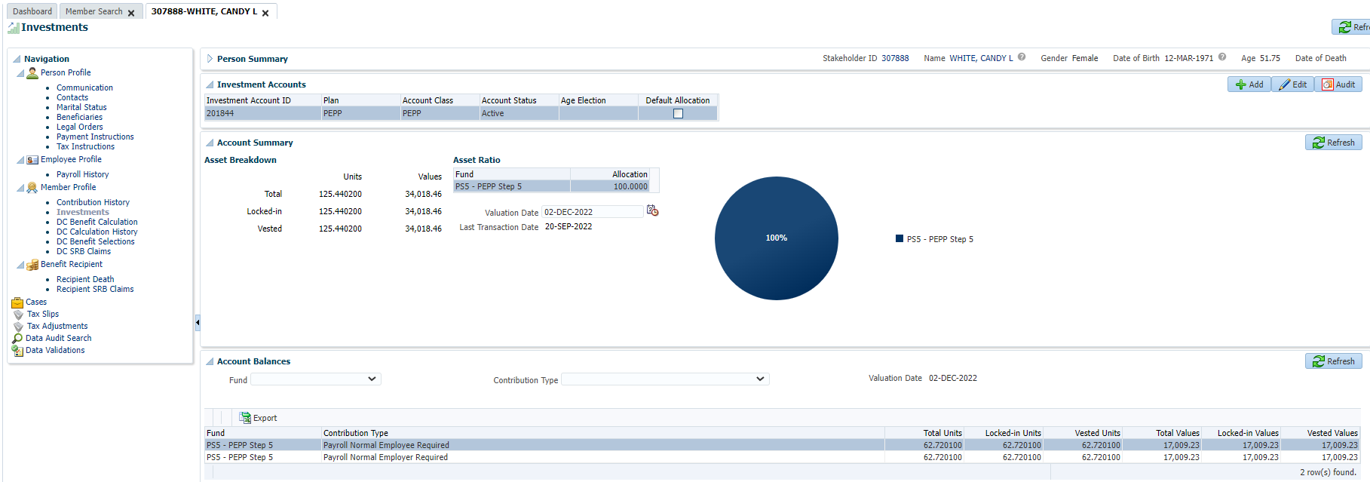

Add DAI for new asset allocation fund (backdated):

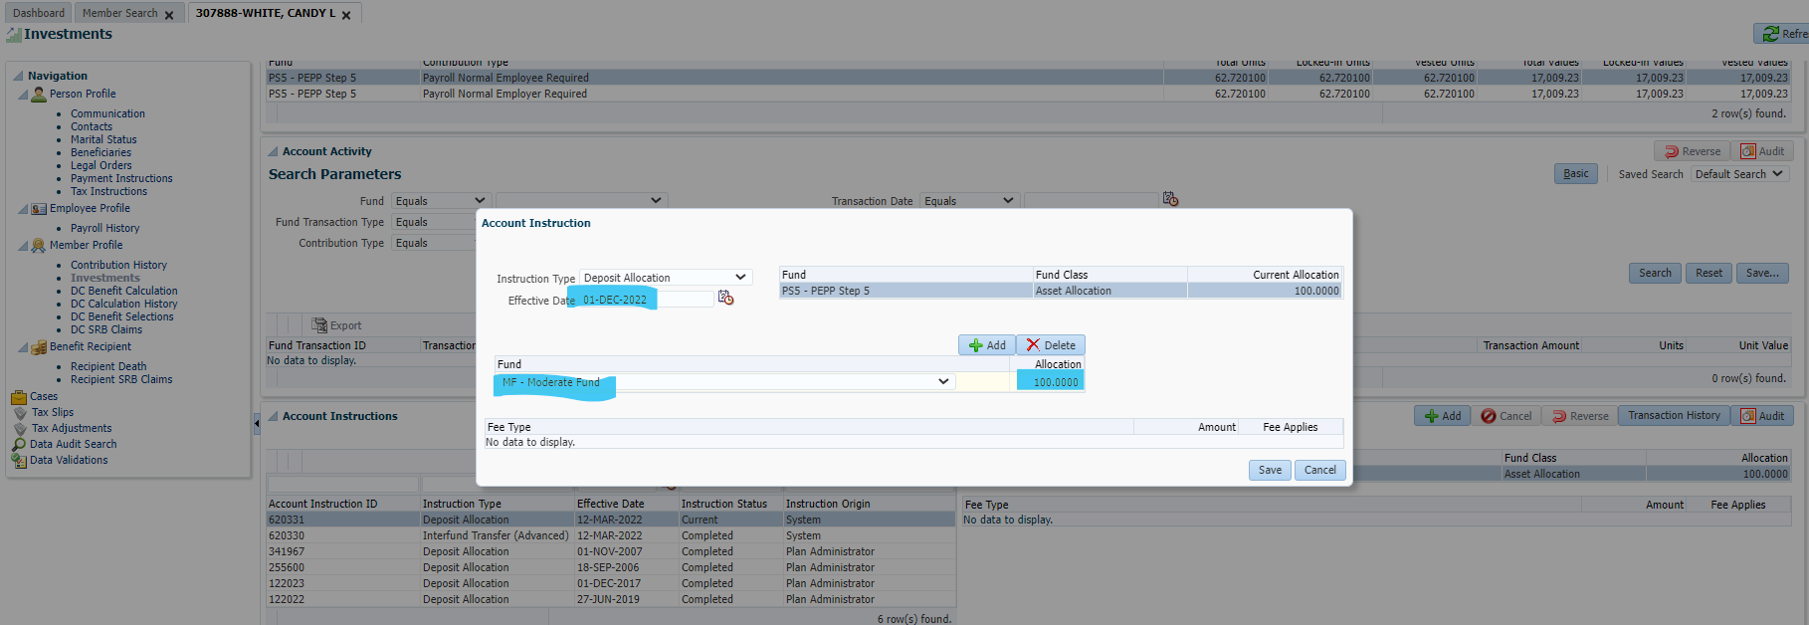

Process interfund transfer with an effective date of Dec 1, 2022 (to match DAI)

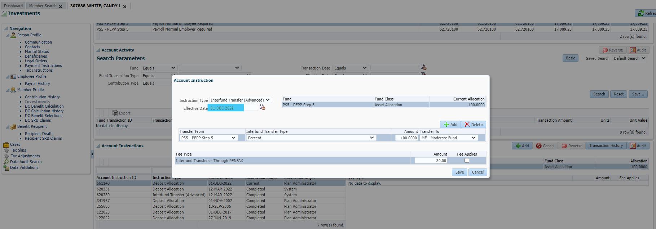

Will check after PIT runs (next day) to confirm, that funds moved to moderate, unit values used were as of Dec 1st & that the breakage occurrence is recorded.

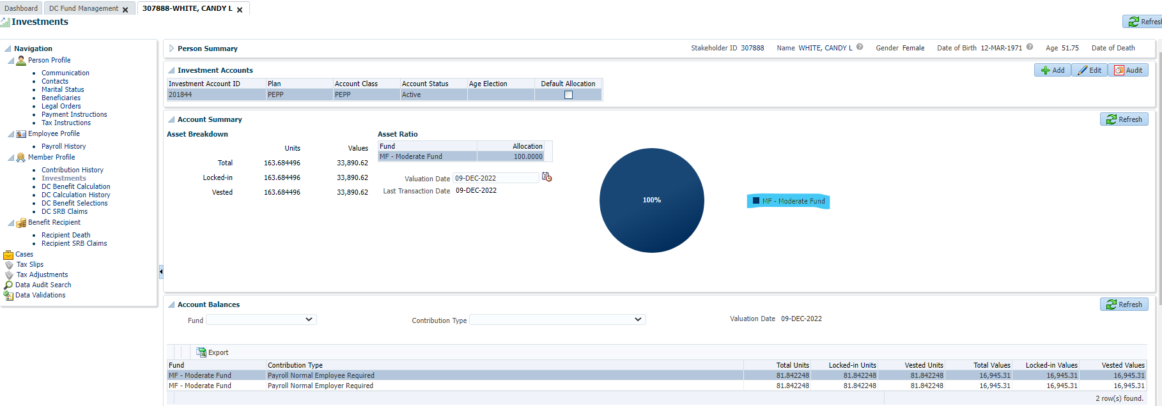

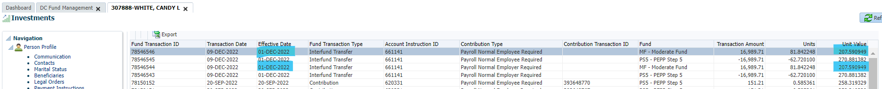

Confirming correct unit values:

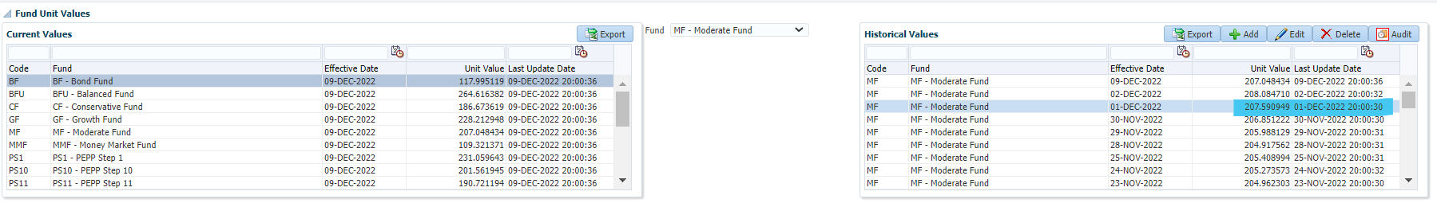

Checking Breakage Occurrences:

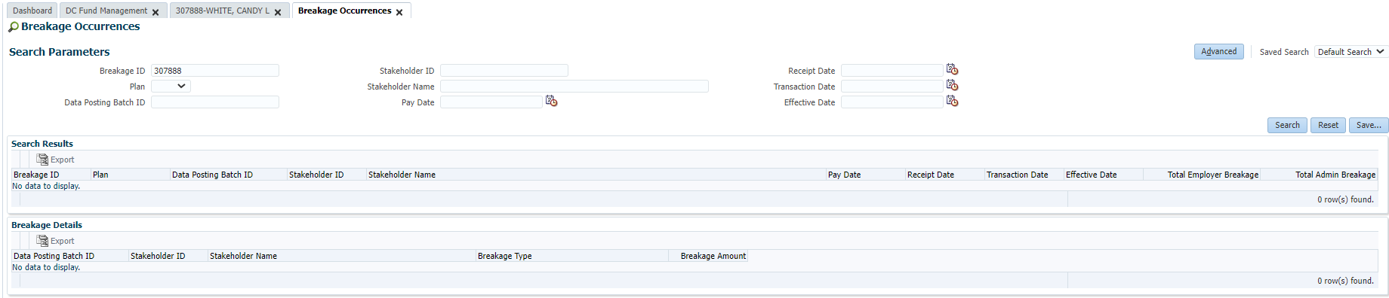

No breakage showing for this transaction, breakage type is correct.